Student’s name | …………………………………………………….…… | Grade | 1
Subject | Computer | Week No. | 6
Lesson Title | Parts of Computers | Unit
Worksheet No. ( 6 ) (Answer)
Instruction: write their names next to it.

Monitor
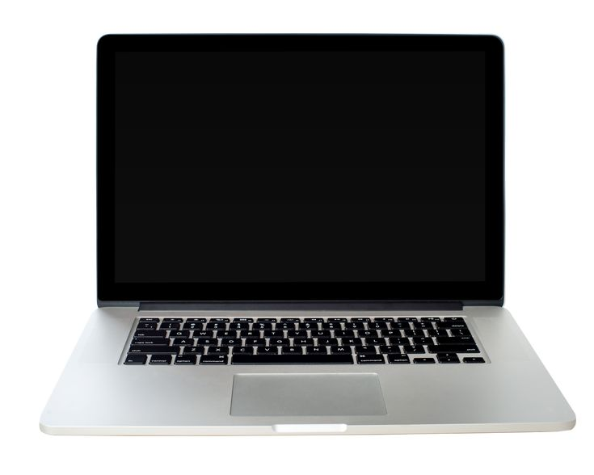
Laptops
Touchpad
Keyboard
Good Luck

